**Mapping platelet response to thrombin using high-sensitivity platelet proteomic analysis**

Yvonne Kong1,2,3, *Callum Houlahan1,3, Bede Johnston1,3, Michelle Cielesh4, Paul Coleman1,5, Mark Larance, Freda Passam1,2,3*

1The Heart Research Institute, Newtown, Australia, 2Royal Prince Alfred Hospital, Camperdown, Australia, 3Sydney Medical School, University of Sydney, Australia, 4Charles Perkins Centre, University of Sydney, Australia, 5Centenary Institute of Cancer Medicine and Cell Biology, University of Sydney, Australia

**Aim:**Platelets respond to agonists (e.g. thrombin) by the secretion of intracellular proteins and mediators which promote thrombus formation [1]. There are limited studies regarding global protein changes after thrombin stimulation in healthy individuals [2]. Our study aims to establish high-quality characterisation of the healthy platelet proteome, at baseline and after thrombin stimulation.

**Method:**Platelets were isolated from whole blood from healthy volunteers. Baseline PAC-1 and CD62P expressions were determined by flow cytometry. Platelets were stimulated with submaximal (0.025U/mL, n=5) and high dose (0.20U/mL, n=6) thrombin. Proteins from the platelet releasate and lysate were identified and quantified using the Thermo Lumos Tribrid Orbitrap mass spectrometer. Protein secretion was determined using a novel method of protein abundance anti-correlation between the lysate and releasate. Statistical analysis was by R and plotted using Tableau. Significance was determined using a repeated-measures one-way ANOVA for activation (resting vs thrombin) at P<0.05.

**Results:** Platelet activation markers PAC-1 and P-selectin were expressed on <0.5% and <15 % of isolated platelets respectively. Plasma contamination of the platelet preparation was <0.5%. Qualitative changes were seen in platelet proteins secreted after high (**Figure 1**) and submaximal dose thrombin, with 203 and 74 proteins that were significantly increased respectively. There was a significant increase in proteins associated with platelet aggregation (e.g. thrombospondin-1) as expected, but also proteins associated with inflammation (e.g. CXCL3), angiogenesis (e.g. VEGF-C) and yet undetermined platelet functions (e.g. alpha-(1,6)-fucosyltransferase) [3].

Figure 1 (right): Platelet releasate and lysate proteomes after stimulation with thrombin 0.2 U/ml. Dots represent individual proteins. Proteins in orange are significantly increased in the releasate and decreased in the lysate following stimulation.

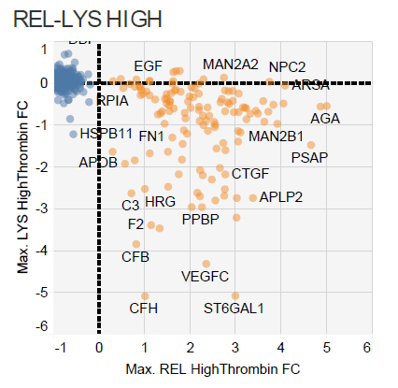

Platelet releasate (Thrombin = 0.2UmL)

Platelet lysate (Thrombin = 0.2UmL)

**Conclusion:** Our platelet proteomic platform provides a resource to study proteins mobilized by platelets for a spectrum of functions, beyond haemostasis. Further investigations regarding proteomic differences and post-translational modifications may yield novel protein markers and therapeutic targets in disease states.

***References***

*[1]. Burkhart JM, et al. The first comprehensive and quantitative analysis of human platelet protein composition allows the comparative analysis of structural and functional pathways. Blood. 2012;120(15):e73-82.25.*

*[2]. van Holten TC, et al. Quantitative proteomics analysis reveals similar release profiles following specific PAR-1 or PAR-4 stimulation of platelets*. *Cardiovascular research. 2014;103(1):140-6.1.*

*[3]. Koupenova M, et al. Circulating Platelets as Mediators of Immunity, Inflammation, and Thrombosis. Circulation research. 2018;122(2):337-51.*