**Title:** Endoplasmic reticulum (ER) stress activation determines megakaryocyte and platelet ER chaperone distribution.

**Aim:**

Platelet ER stress contributes to platelet activation and thrombosis and presents a potential target for antithrombotic therapy. Megakaryocyte endoplasmic reticulum (ER) stress has been shown to contribute to thrombopoiesisand thrombosis, but limited data exists on how disease states such as diabetes mellitus (DM) affects megakaryocyte ER stress. Additionally, whether ER stress leads to redistribution of prothrombotic ER-resident proteins, such as protein disulfide isomerase (PDI) and ERp5, to the platelet surface remains unknown.

**Method:**

Femurs were isolated from murine models of type 1 DM with hyperlipidaemia (ApoE-/- ± streptozotocin) and type 2 DM (outbred mice on high fat diet). ER proteins were visualised by immunofluorescence microscopy in bone marrow cryosections. Healthy human donor platelets were treated with ER calcium mobilisers thapsigargin (TG) or 2,5-di-(tert-butyl)-1,4-benzohydroquinone (BHQ), and platelet surface CD62P, ERp5, PAC-1 and PDI were determined by flow cytometry. Platelet released proteins were analysed by Western blot.

**Results:**

Activation of the inositol-requiring enzyme 1 (IRE1) pathway, an evolutionarily conserved ER stress pathway, was increased in diabetic megakaryocytes (Figure 1A and 1B). Increased PERK pathway activation, indicated by phospho-eIF2α, was only seen in megakaryocytes from the hyperglycaemic ApoE-/- mice (Figure 1A). Megakaryocyte ER stress was accompanied by upregulation of some ER chaperones, such as PDI, but not others, such as ERp5 (Figure 1A). Human platelets were activated after TG and tBHQ treatment. However, only TG treated human platelets demonstrated IRE1 pathway activation, and increased surface, but not released, PDI and ERp5.

**Conclusion**

We propose metabolic derangements such as hyperlipidaemia and hyperglycaemia can lead to megakaryocyte ER stress. This is accompanied by upregulation of some ER chaperones within the megakaryocytes. Importantly, ER stress appears to contribute to thrombosis by increasing platelet surface prothrombotic molecules, but not necessarily their secretion.

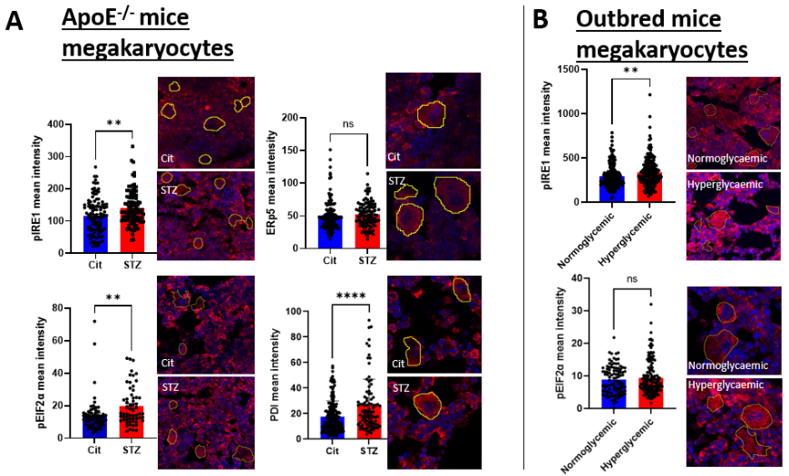

**Figure 1 (left). ER stress pathways are differentially activated in murine models of A) hyperlipidaemic type 1 compared to B) type 2 DM.** Megakaryocyte ER stress is associated with the induction of some but not all ER chaperones. ** indicates p of 0.001 to 0.01, **** indicates p<0.0001, Mann Whitney U test.